**File system**

A file system is a process that manages how and where data on a storage disk, typically a hard disk drive (HDD), is stored, accessed and managed. It is a logical disk component that manages a disk's internal operations as it relates to a computer and is abstract to a human user.

**Windows file system**

Microsoft Windows employs two major file systems: NTFS, the primary format most modern versions of this OS use by default, and FAT, which was inherited from old DOS and has exFAT as its later extension.

**NTFS**

New Technology File System By Tobias Geisler Mesevage

**NT file system** (NTFS), which is also sometimes called the **New Technology File System**, is a process that the Windows NT operating system uses for storing, organizing, and finding files on a hard disk efficiently. NTFS was first introduced in 1993, as apart of the Windows NT 3.1 release.

**FAT**

File Allocation Table

**File Allocation Table** (FAT) is a file system developed for personal computers. Originally developed in 1977 for use on floppy disks, it was adapted for use on hard disks and other devices.

**LINUX / UNIX**

Linux supports numerous file systems, but common choices for the system disk on a block device include the **ext**\* family (**ext2**, **ext3** and **ext4**), **XFS**, **JFS**, and **btrfs**. For raw flash without a flash translation layer (FTL) or Memory Technology Device (MTD), there are UBIFS, JFFS2 and YAFFS, among others.

**EXT**

extended file system

The extended **file system**, or **ext**, was implemented in April 1992 as the first **file system** created specifically for the Linux kernel.

**JOURNALING FILE SYSTEM**

A journaling file system is a file system that keeps track of changes not yet committed to the file system's main part by recording the intentions of such changes in a data structure known as a "journal", which is usually a circular log.

Since NTFS is a journaling file system, it can auto-repair the internal data structures that are used to keep track of files, so the drive itself remains logically consistent. The file is correctly set to the final size, and its directory entry is properly linked in

**JOURNALING WORKING IN WINDOWS**

The NTFS change journal creates a log of any added, deleted, or modified files. The biggest advantage of the NTFS system is that all journaling is done before any changes are made to the disk. ... Surprisingly, some experts do recommend that users turn off NTFS journaling to improve system performance.

**JOURNALING WORKING IN LINUX**

The ext4 journaling file system or fourth extended filesystem is a journaling file system for Linux, developed as the successor to ext3. ... 28, containing the ext4 filesystem, was finally released on 25 December 2008. On 15 January 2010, Google announced that it would upgrade its storage infrastructure from ext2 to ext4.

**TYPES OF FILE SYSTEM AND THE FILE SYSTEM SUPORTS**

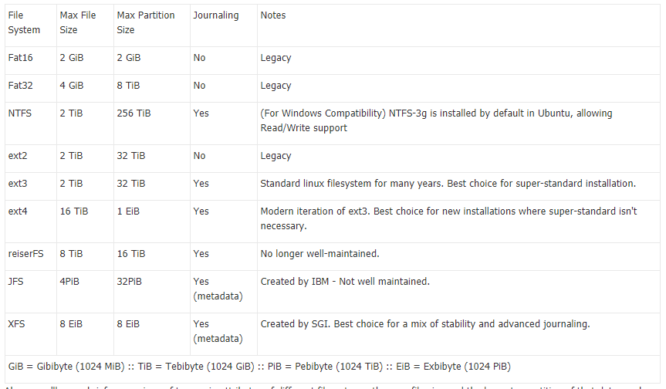

# FRAGMENTATION

Another common Windows practice that is not needed in Unix is defragmenting the hard drive. When NTFS and FAT write files to the hard drive, they don't always keep pieces (known as blocks) of files together. Therefore, to maintain the performance of the computer, the hard drive needs to be "defragged" every once in a while. This is unnecessary on Unix File systems due to the way it was designed. When ext3 was developed, it was coded so that it would keep blocks of files together or at least near each other.

No true defragmenting tools exist for the ext3 file system, but tools for defragmenting will be included with the ext4 file system.

**WHAT IS THE FUNDAMENTAL DIFFERENCE BETWEEN WINDOWS AND LINUX FILE SYSTEM**

